**Low Level Control System**

***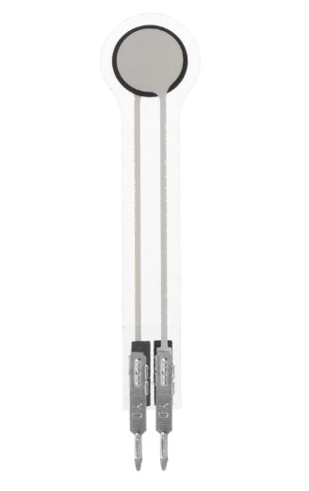*Hand Sensor Comparison and Specs**

**FORCE SENSOR OPTIONS:**

***Model:***  Force Sensitive Sensor (Film Pressure Sensor - 20kg) **(FSR)**

***Number of Sensors:*** 5 (one for each finger) + extra palm Sensor

***Price:*** 95LE per sensor at Future Electronics

***Specifications:***

* Load capacity: 0 - 20kg.
* Outer diameter: 9mm
* Sensing inner diameter: 7.5mm
* Overall length: 45mm
* Resistance Range: Infinite (no pressure) to 200Ω (max pressure)

**Note:** It is advised to fix the sensor on a flat surface for consistent readings. Calibration will be needed for better accuracy.

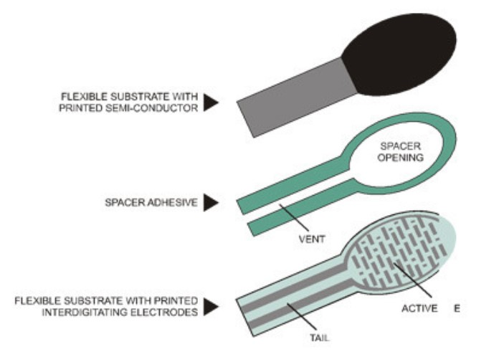

***How it Works:***

Force Sensing Resistors (FSRs) are sensors that allow you to detect physical pressure, squeezing and weight.   
 The FSR is made of 2 layers separated by a spacer. The more one presses, the more of those Active Element dots touch the semiconductor and that makes the resistance go down. This action reduces the resistance of the sensor.

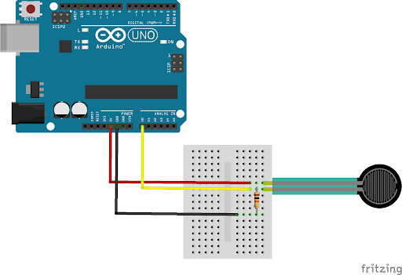***Reading Sensor Data:***

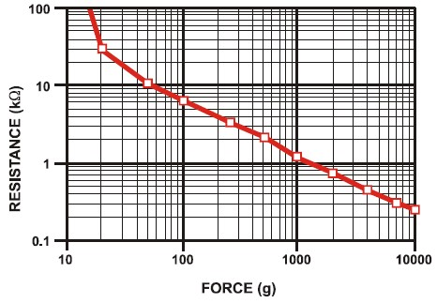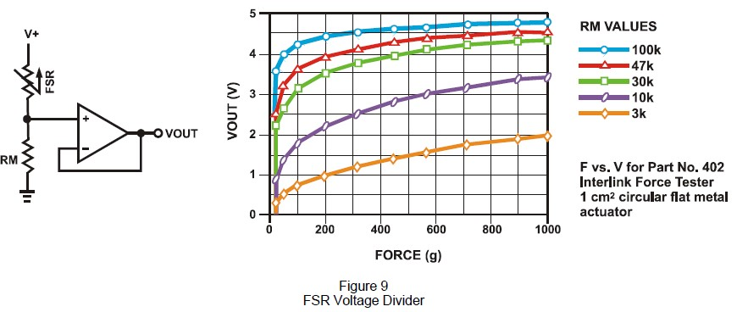 As seen from the concept driving this sensor operation, we can read force changes based on the change in resistance value of the FSR. This can be done by having a voltage divider circuit in which analog voltage signal enters the microcontroller. As in the following configuration, as more pressure is applied, FSR resistance decreases and a higher voltage signal enters the microcontroller.

***Model:***  Force Sensitive Sensor (Capacitive Pressure Sensor) **(CFS)**

***Number of Sensors:*** 5 (one for each finger) + extra palm Sensor

***Price:*** $20 per sensor at online shops like singletact.com

***Specifications:***

* Load capacity: 0 - 10kg.
* Outer diameter: 8mm
* Overall thickness: 0.35mm
* Highly sensitive and repeatable sensors provide errors less than 1.0%
* Simple Analog 3-wire interface for immediate DAQ integration

**Note:** It is advised to fix the sensor on a flat surface for consistent readings. Special Electronic Circuits will be needed to measure the capacitance of the sensor as it changes with the force applied.

***How it Works:***

Delivering superior sensitivity and repeatability over resistive force sensors. The ultra-thin capacitive force sensor 8 mm 100N by SingleTact is very accurate and easy to use with a repeatability error less than 1% of FSR. The single-element capacitive sensor accurately and reliably quantifies forces and delivers incredible performance. By having an elastic dielectric material between two plates, the sensor can measure the deformation in the dielectric material as pressure increases by directly measuring the capacitance of the transducer.

***Reading Sensor Data:***

Unlike FSR, Capacitive sensor requires extra board to make it compatible with DAQ boards and enable usage with analog pins on microcontrollers. Users can implement their own circuitry to measure the sensor’s capacitance and calibrate it to force values. OEM board costs $30, so it might be cheaper to find other methods to measure the sensor value.

**POSITION & ORIENTATION FEEDBACK SENSOR OPTIONS:**

***Model:*** Flex Sensor 5.6 cm (Detect Bending Motion) `

***Number of Sensors:*** 5 (One for each finger)

***Price:*** 210.00 EGP from RAM Electronics

***Specifications:***

* Bending capacity: measure bindings form 0 degrees up to 90 degrees
* Dimensions: 5.6 cm length

***How it Works:***

The sensor acts like a variable resistance where at no bending the sensor

resistance is about 30 KOhm and as the bending angle increase the

resistance of the sensor increases till maximum 90 degrees bending which

corresponds about 70 KOhm in resistance.

**Note:** Sensor must be bent in only one direction (Away from the ink) as

bending in the other direction will not generate any reliable data and may

damage the sensor.

***Reading sensor data:***

By combining the sensor in a simple voltage divider circuit, the change in

the sensor resistance can be detected as a change in a node voltage

(Analog signal) which can be read then by the Analog to Digital

Converter hardware of the microcontroller.

**Note:** The fixed resistor in the circuit recommended to be from 10

KOhm to 100KOhm.

***Model:*** Rotary Position Sensor (Joint Motion) (3382G-1-103G)

***Number of Sensors:*** 5 (One for each finger)

***Price:*** $2.5 from online stores (exclude shipping)

***Specifications:***

* Resistance Range: 2.5K to 10K
* Dimensions: 12mm
* # of continuous rotations: 1
* Max # of cycles: 1Million
* Get Mechanical Dimensions from:

<https://www2.mouser.com/ProductDetail/Bourns/3382G-1-103G?qs=AgBp2OyFlx%2FKuZqq5DE8cg%3D%3D>

***How it Works:***

This Analog Sensor acts as a potentiometer that changes its resistance value as the shaft rotates the inner wiper. The device is used in closed loop feedback control systems with its compact design that allows for addition in limited spaces. Three terminals of the sensor represent the minimum, maximum, and current resistance value.

***Reading sensor data:***

The sensor is used by activating the ADC of the MCU. Reading data directly from the sensor is possible without the need for any hardware filtration. Although some software filtration might be needed for optimal results.

**Note:** The maximum tolerated voltage by the sensor is 16V. please note that the sensor is intended for SMD boards, so take care while soldering wires to the sensor pins and make sure the sensor is fixed in place in the design before any trials to avoid damaging the sensor.

 ***Model:*** MPU6050 IMU “3-Axis Accelerometer Gyroscope 6DOF module. “

***Number of sensors used:*** 2

***Price:*** 95LE at RAM Electronics.

***Specification:***

* Dimensions (in millimeters): D*E*A = 4.00*4.00*0.90.
* Gyroscope features: Digital-output X-, Y- and Z-Axis angular rate sensors (gyroscopes) with a user-programmable full-scale range of ±250, ±500, ±1000 and ±2000 °/sec.
* Accelerometer features: Digital-output triple-axis accelerometer with a user-programmable full-scale range of ±2g, ±4g, ±8g and ±16g.

***How it Works:***

The MPU6050 IMU has both 3-Axis accelerometer and 3-Axis gyroscope integrated on a single chip.

The gyroscope measures rotational velocity or rate of change of the angular position over time, along the X, Y and Z axis. It uses MEMS technology and the Coriolis Effect for measuring. The outputs of the gyroscope are in degrees per second, so to get the angular position we just need to integrate the angular velocity.

The accelerometer measures gravitational acceleration along the 3 axes and using some trigonometry math we can calculate the angle at which the sensor is positioned. So, if we fuse, or combine the accelerometer and gyroscope data we can get very accurate information about the sensor orientation.

***Reading Sensor Data:***

As seen from the previous concept driving this sensor operation, we know the orientation of sensor and the object that it has been attached to based on the change in the orientation of axes of sensitivity and polarity of rotation.

We are using for communication I2C protocol for communication with the Arduino, so we need only two wires for connecting, plus the two wires for powering.

**TEMPERATURE SENSOR OPTIONS:**

***Model:*** MLX90614 infrared temperature sensor

***Number of Sensors:*** 1 in Palm

***Price:*** 410 LE from Future Electronics

***Specifications:***

* Operating voltage: 3.3 ~ 5V
* object temperature: -70 to +380°C
* High accuracy of 0.5°C over wide temperature range
* I2C interface

***How it Works:***

The temperature sensor measures the infrared radiation of surrounding objects and compares it to that of the environment. It can identify temperature without physical contact to the object, giving the bionic arm a major advantage in sense restoration for amputees. It can measure infrared emission by focusing it on a photodetector that outputs a voltage level proportional to the infrared radiation.

**Note:** the sensor requires a line of sight with the object being measured to have a path to measure infrared radiation. Also, the sensor should be slightly recessed in the palm to avoid damaging the sensor while grasping objects. Note that the sensor by itself is cheaper (at 185 LE), but the module having some amplification and communication protocols for convenience is more expensive.

***Reading Sensor Data:***

The module has 4 pins two of which are for power delivery. The other 2 are for communication (I2C) with the MCU. Pull up resistors are added in the module and no need to add them externally. Cheaper versions of the thermometer require further amplification and more electronic circuitry. Analog data read by the MCU can then be calibrated for temperature readings.

**Note:** There are many types of temperature sensors, but all other types require physical contact with the measured object, which is why they are rejected.